# Chapter 8

Data set global_economy contains the annual Exports from many countries. Select one country to analyse.

Country selected: **United Kingdom**

## a. Plot the Exports series and discuss the main features of the data.

library(fpp3)

library(dplyr)

economy <- global_economy %>%

filter(Country == "United Kingdom") %>%

select(Year, Exports)

economy %>%

autoplot(Exports) +

labs(x="Year", y="Exports") +

theme_minimal() +

theme(

axis.title.x = element_text(size = 16, hjust = 0.5),

axis.title.y = element_text(size = 16),

axis.text.x = element_text(size = 14),

axis.text.y = element_text(size = 14),

legend.title = element_text(size = 16),

legend.text = element_text(size = 14)

)

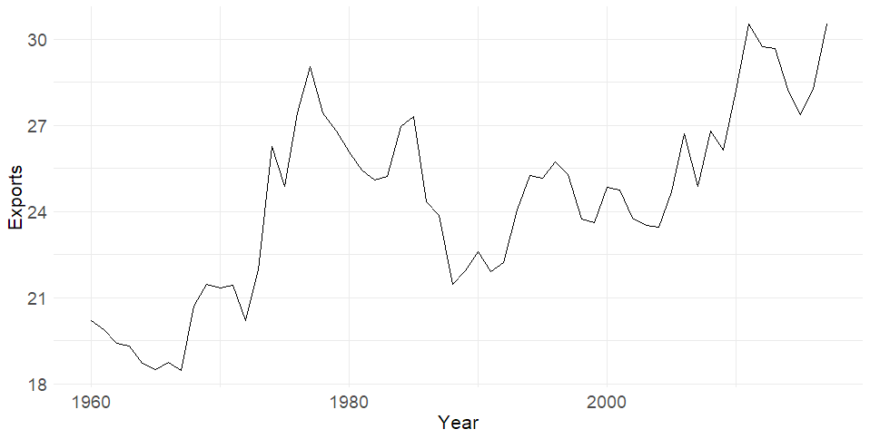

Figure 1: United Kingdom Exports over time

The graph shows exports of the US over time, spanning from around 1960 to close to 2020. The overall trend is upward, indicating that exports have generally increased over this period. However, the data also reveals periods of decline and fluctuation, with a big drop before 1990.

## b. Use an ETS(A,N,N) model to forecast the series, and plot the forecasts.

ann_model <- economy %>%

model(ETS(Exports ~ error("A") + trend("N") + season("N")))

next_5_years_ets_ann_forecast <- ann_model %>%

forecast(h = 5)

next_5_years_ets_ann_forecast %>%

autoplot(economy) +

labs(x="Year", y="Exports") +

theme_minimal() +

theme(

axis.title.x = element_text(size = 16, hjust = 0.5),

axis.title.y = element_text(size = 16),

axis.text.x = element_text(size = 14),

axis.text.y = element_text(size = 14),

legend.title = element_text(size = 16),

legend.text = element_text(size = 14)

)

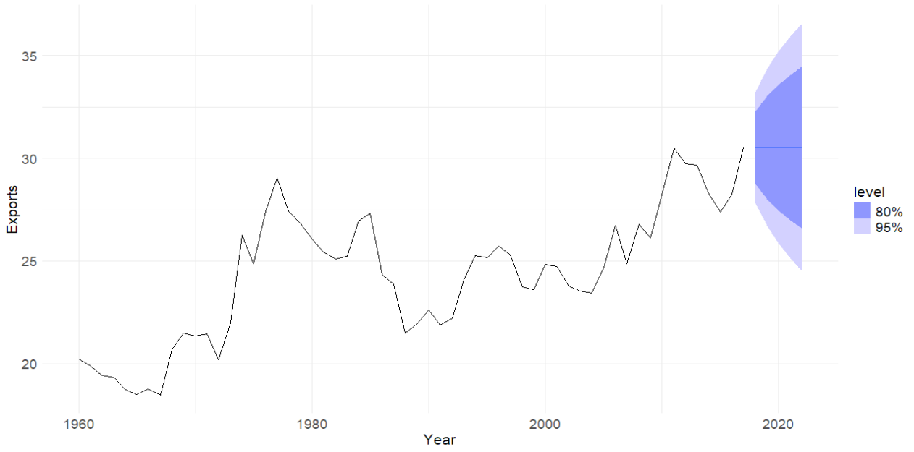

Figure 2: Forecast the United Kingdom's exports in the next 5 years using ETS(A,N,N) model

## c. Compute the RMSE values for the training data.

ann_rmse <- accuracy(ann_model)$RMSE

print(ann_rmse)

1.354533

=> RMSE = 1.354533

## d. Compare the results to those from an ETS(A,A,N) model. (Remember that the trended model is using one more parameter than the simpler model.) Discuss the merits of the two forecasting methods for this data set.

aan_model <- economy %>%

model(ETS(Exports ~ error("A") + trend("A") + season("N")))

next_5_years_ets_aan_forecast <- aan_model %>%

forecast(h = 5)

next_5_years_ets_aan_forecast %>%

autoplot(economy) +

labs(x="Year", y="Exports") +

theme_minimal() +

theme(

axis.title.x = element_text(size = 16, hjust = 0.5),

axis.title.y = element_text(size = 16),

axis.text.x = element_text(size = 14),

axis.text.y = element_text(size = 14),

legend.title = element_text(size = 16),

legend.text = element_text(size = 14)

)

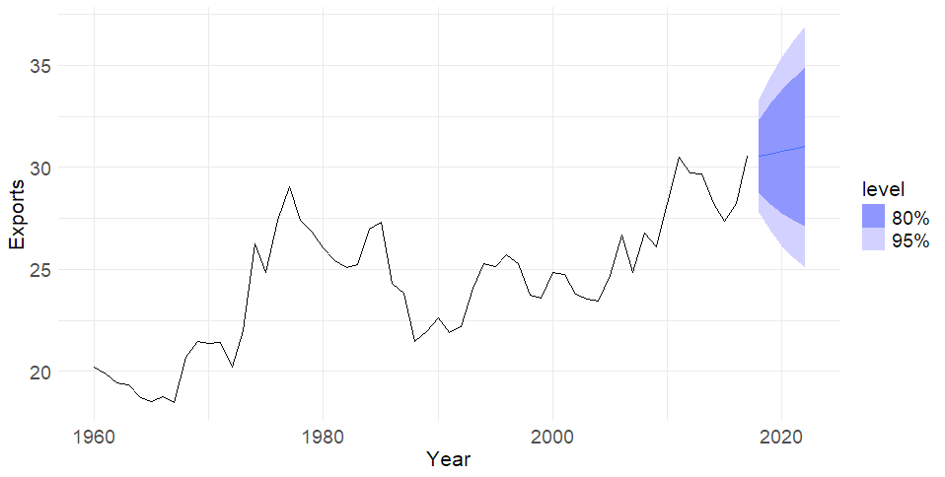

Figure 3: Forecast the United Kingdom's exports in the next 5 years using ETS(A,A,N) model

aan_rmse <- accuracy(aan_model)$RMSE

print(aan_rmse)

1.350896

=> RMSE = 1.350896

## e. Compare the forecasts from both methods. Which do you think is best?

I believe that the ETS(A,A,N) method is better since it captures the increasing trend in the data and has a lower RMSE. Meanwhile, the ETS(A,N,N) method suggests that the exports will stay the same.

## f. Calculate a 95% prediction interval for the first forecast for each model, using the RMSE values and assuming normal errors. Compare your intervals with those produced using R.

* Calculate a 95% prediction interval for the **first forecast** for each model:

ann_first_forecast_mean <- next_5_years_ets_ann_forecast$.mean[1]

aan_first_forecast_mean <- next_5_years_ets_aan_forecast$.mean[1]

ann_95_interval <- ann_first_forecast_mean + c(-1.96, 1.96) * ann_rmse

aan_95_interval <- aan_first_forecast_mean + c(-1.96, 1.96) * aan_rmse

Print results:

print(ann_95_interval)

[1] 27.87352 33.18329

print(aan_95_interval)

[1] 27.90098 33.19649

* Intervals for the **first forecast** for each model calculated by R method:

print(next_5_years_ets_ann_forecast %>%

hilo() %>%

head(1) %>%

select(Year, `95%`))

# A tsibble: 1 x 2 [1Y]

Year `95%`

<dbl> <hilo>

1 2018 [27.82658, 33.23023]95

print(next_5_years_ets_aan_forecast %>%

hilo() %>%

head(1) %>%

select(Year, `95%`))

# A tsibble: 1 x 2 [1Y]

Year `95%`

<dbl> <hilo>

1 2018 [27.80471, 33.29275]95

* Intervals comparison

|  |  |  |
| --- | --- | --- |
|  | Using RMSE value | Using R built-in method |
| ETS(A,N,N) | [27.87352, 33.18329] | [27.82658, 33.23023] |
| ETS(A,A,N) | [27.90098, 33.19649] | [27.80471, 33.29275] |

Result: Very close match between manual and R’s built-in intervals. Both models produce very similar forecast ranges. The ETS(A,A,N) has a slightly wider R-generated intervalbecause it has one more parameter (the trend), which increases uncertainty in the forecast, and therefore slightly widens the prediction interval.